**Pratical 1.Demontration of creating database**

**Name:Monish Sudhir Naik Div:A Roll no:87**

**\*\*\*\*\*\*\*\*\*\*\*\*\*\*\*\*\*\*\*\*\*\*\*\*\*\*\*\*\*\*\*\*\*\*\*\*\*\*\*\*\*\*\*\*\*\*\*\*\*\*\*\*\*\*\*\*\*\*\*\*\*\*\*\*\*\***

create database monish;

use monish;

**OUTPUT**:

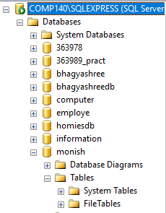

**Pratical 2.Create table insert 10 records in it.**

**Name:Monish Sudhir Naik Div:A Roll no:87**

**\*\*\*\*\*\*\*\*\*\*\*\*\*\*\*\*\*\*\*\*\*\*\*\*\*\*\*\*\*\*\*\*\*\*\*\*\*\*\*\*\*\*\*\*\*\*\*\*\*\*\*\*\*\*\*\*\*\*\*\*\*\*\*\*\*\***

create database management;

use monish;

CREATE TABLE employe_details(

emp_id VARCHAR(8),

emp_name VARCHAR(20),

emp_dept_id VARCHAR(20),

emp_age INT)

INSERT INTO employe_details VALUES('E40001','MONISH','E101',21);

INSERT INTO employe_details VALUES('E40002','VISHVESH','E102',21);

INSERT INTO employe_details VALUES('E40003','VIJAY','E103',21);

INSERT INTO employe_details VALUES('E40004','VEDANT','E104',21);

INSERT INTO employe_details VALUES('E40005','JAGDISH','E105',21);

INSERT INTO employe_details VALUES('E40006','NARUU','E106',21);

INSERT INTO employe_details VALUES('E40007','ADITYA','E107',21);

INSERT INTO employe_details VALUES('E40008','RISHI','E108',21);

INSERT INTO employe_details VALUES('E40009','KHUSHAB','E109',21);

INSERT INTO employe_details VALUES('E40011','RAJ','E1010',21);

SELECT*FROM employe_details

**OUTPUT**:

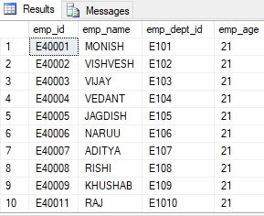

**Pratical 3.Demonsrate to insert update and delete. Date : 10.02.2024**

**Name:Monish Sudhir Naik Div:A Roll no:87**

**\*\*\*\*\*\*\*\*\*\*\*\*\*\*\*\*\*\*\*\*\*\*\*\*\*\*\*\*\*\*\*\*\*\*\*\*\*\*\*\*\*\*\*\*\*\*\*\*\*\*\*\*\*\*\*\*\*\*\*\*\*\*\*\*\*\***

USE monish

SELECT * from employe_details;

update employe_details

set emp_name='VISHVESH' where emp_dept_id='E102';

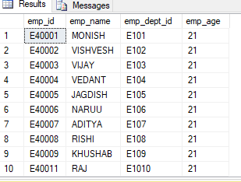

delete employe_details where emp_dept_id='E1010'

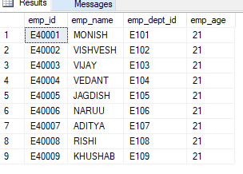

**Pratical 5.Demonstrate to Alter Table (Add Column, Delete Column, Rename, Modify Column Date : 17.02.2024**

**Name:Monish Sudhir Naik Div:A Roll no:87**

1.Add

use monish;

select * from dbo.employe_details;

alter table employe_details

add

contacts varchar;

address varchar;

OUTPUT:

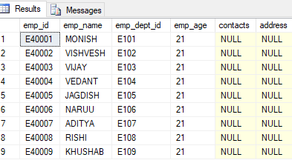

2.DROP

use monish;

select * from dbo.employe_details;

alter table employe_details

drop column

OUTPUT:

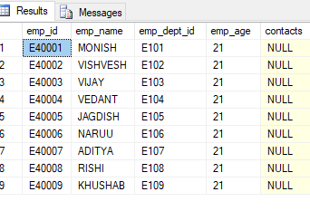

3.RENAME

use monish;

select * from dbo.employe_details;

Exec sp_rename 'employe_details.contacts','address','column';

OUTPUT:

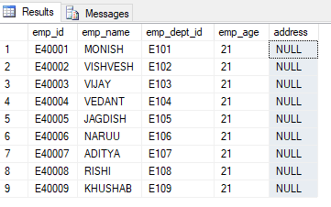

4.MODIFY:

use monish;

select * from dbo.employe_details;

alter table employe_details

alter column emp_dept_id varchar (73);

OUTPUT:

